Certificate of Health

of OSU Summer school participant

Name
Name | Family Name | First Name
Sex | □ Male | □ Female
Date of Birth (YYYY/MM/DD) |  | Age:

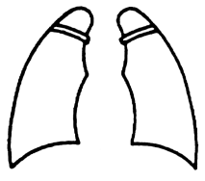
Please describe the results of the physical and X-ray examinations of applicant’s chest, also note the exact date of the x-ray
(X-rays taken more than 6 months prior to certification are NOT valid).

Cardiomegaly □ □ □

(+) (±) (-)

Date : Film No.

Please indicate with x or – and fill in date of recovery

Please indicate necessary information

Tuberculosis | □ | / / | Malaria |  | □ | / / | Rheumatic Fever | □ | / /
Epilepsy | □ | / / | Renal Disease |  | □ | / / | Cardiac Diseases | □ | / /
Diabetes | □ | / / | Allergy |  | □ | / / | Mental disorders | □ | / /
Functional Disorder of extremities |  |  | □ | / / |  | Other infectious diseases |  | □ | / /

Physician Signature :

Physician’s Name in Print:

Office/Institution

Address:

*The Provided Information is to be kept confidential and used only for the procedures of the Orenburg State University summer school

